Mid-Term Project Report

# 1. Project Overview:

Project Name: Housing Price Trend Analysis and Affordability Modeling

Report Date: June 15, 2025

Project Manager: Kalle Reaves

Report Period: May 29 – June 15, 2025

# 2. Project Status:

Overall Status: On Track, with minor delays in modeling phase

Key Accomplishments:

- Completed data collection from Zillow, Census, BEA, and the Federal Reserve  
- Built and populated the SQL database schema  
- Performed initial data cleaning and exploratory data analysis (EDA)

Key Issues/Risks:

- Slight delay in modeling start due to complex hpi data

-Need to figure out how to include more data in LSTM model

Upcoming Milestones:

- Complete predictive modeling and validation (Week 7)  
- Begin geospatial visualizations and Tableau dashboards (Week 8)  
- Draft project interpretation and begin writing final report (Week 9)

# 3. Detailed Information:

Schedule:

- Project Start: May 29, 2025  
- Mid-point Check-in: June 15, 2025  
- Project End: August 1, 2025  
- Key Milestones completed:  
 • Data Collection (Week 3)  
 • SQL Schema Design & Population (Week 4)  
 • EDA & Cleaning (Week 5)  
 • Feature Engineering (In Progress - Week 6)  
 • Modeling (Starting Week 6)

Budget:

No formal budget. Open-source tools and free academic datasets are being used.

Resource Allocation:

- Personnel: Kalle Reaves (Sole Analyst)  
- Software: Python, PostgreSQL, Tableau  
- Hardware: Personal computer and cloud backups

Task Breakdown:

|  |  |  |  |
| --- | --- | --- | --- |
| Task | Status | Assigned To | Completion Date / ETA |
| Data Collection | Complete | Kalle Reaves | Week 3 |
| SQL Schema Setup | Complete | Kalle Reaves | Week 4 |
| EDA & Cleaning | Complete | Kalle Reaves | Week 5 |
| Feature Engineering | In Progress | Kalle Reaves | Week 6 |
| Modeling | Pending | Kalle Reaves | Week 7 |
| Visualization | Upcoming | Kalle Reaves | Week 8 |

Performance Metrics:

- Tasks Completed On Time: 4/5 (80%)  
- Overall Timeline Adherence: on track  
- KPIs (CPI/SPI): Not formally tracked due to no cost baseline

# 4. Communication:

Stakeholder Communication Plan:

- Weekly video updates to faculty advisor  
- Mid-term and final written reports  
- End-of-project presentation with visual walkthroughs

Meeting Minutes:

- Week 2: Scope reviewed and approved  
- Week 4: Database schema validated  
- Week 5: EDA findings shared  
- Week 6: Discussed early feature engineering results

# 5. Next Steps:

Action Items:

- Finalize all new variables for modeling  
- Launch time series and regression models  
- Begin generating ZIP-level geospatial visualizations

Contingency Plans:

- If modeling falls behind: Simplify regression models and rely more on EDA visuals  
- If Tableau fails for mapping: Use Python for heat maps

# 6. Appendices

**WBS**

**1. Project Planning & Management**

1.1 Define project objectives and scope  
1.2 Identify data sources (Kaggle, Zillow, Census, BEA, etc.)  
1.3 Develop project timeline  
1.6 Schedule regular progress checkpoints

**2. Data Collection**

2.1 Research housing price datasets  
2.2 Download Zillow historical housing price data  
2.3 Collect inflation rate data from BEA  
2.4 Gather interest rate data from Federal Reserve  
2.5 Collect demographic/economic data from U.S. Census  
2.6 Acquire property-level data with location and features  
2.7 Document metadata and data sources

**3. Data Storage & Organization**

3.1 Design SQL database schema  
3.2 Create SQL tables for each dataset  
3.3 Populate tables with collected data  
3.4 Normalize and index SQL tables  
3.5 Back up SQL database

**4. Data Cleaning & Preprocessing**

4.1 Handle missing values  
4.2 Remove duplicates  
4.3 Standardize data formats   
4.4 Convert SQL tables to pandas DataFrames  
4.5 Perform exploratory data analysis (EDA)  
4.6 Merge data across sources by ZIP code/state

**5. Feature Engineering**

5.1 Create new variables (e.g., price per square foot)  
5.2 Encode categorical variables  
5.3 Create dummy variables for amenities  
5.4 Normalize/standardize numerical features  
5.5 Generate time-based features for time series analysis

**6. Statistical & Predictive Analysis**

6.1 Conduct correlation analysis  
6.2 Perform linear regression to assess price factors  
6.3 Run multivariate regression analysis  
6.4 Conduct time series analysis   
6.5 Test models for inflation-adjusted pricing  
6.6 Evaluate model accuracy

**7. Geospatial & Visual Analysis**

7.1 Map housing prices by ZIP code and state  
7.2 Create heat maps of housing cost increases  
7.3 Visualize inflation-adjusted housing price trends  
7.4 Plot bubble charts of most impactful features  
7.5 Generate time series graphs of price growth  
7.6 Build dashboards using Tableau or similar tools

**8. Interpretation & Reporting**

8.1 Summarize key findings from regression models  
8.2 Compare price increases to inflation  
8.3 Interpret geospatial trends  
8.4 Predict future housing affordability  
8.5 Write detailed project report  
8.6 Include graphs and visualizations in report

**9. Deliverables & Submission**

* 9.1 Prepare final Python/Jupyter Notebooks  
  9.2 Prepare and document SQL source code  
  9.3 Export all visualizations (PNG/interactive)  
  9.4 Compile and organize results of models  
  9.5 Submit full project package (code, vis
* Gantt chart or schedule tracker

Current HPI predictive model

Top of Form

CuCcccccccC

Housing database schema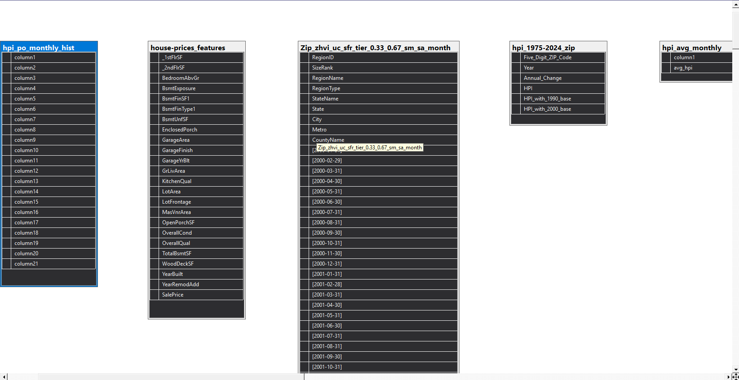Bottom of Form

**Link to GitHub with python script**

<https://github.com/kdizil117/seniorcapstone>

**Link to Gantt chart(30 day trial with ganter on google)**

<https://drive.google.com/file/d/1bAqKNW5pS_HGGWR5noAgnisGNPcr3XUw/view?usp=sharing>